(Approx. 274 words)

"Ambassador" Interpreter
By George Harding, Treasurer, Tucson Computer Society
www.aztcs.org
actuary110 (at) yahoo.com

If you travel outside the United States, this is a product you need. It allows you to speak and understand 20 languages and 42 dialects.

It has an over-the-ear headphone but can also be used through an app or text. It can even be broadcast live in a conference environment!

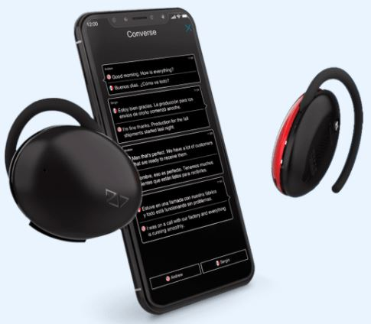

What is especially useful for this product is that it can be used for fluid ongoing conversations, unlike other translation apps and handheld devices which are best for short, occasional conversations.

There are three modes in which it can be used:
- Listen mode provides seamless personal translation in the selected language within 8 feet or so and automatically translates to the user in their native language. It also provides the translation as text with an accompanying app.
- Lecture mode broadcasts the words of the speaker wearing the device to people in a lecture or conference setting and streams audio translations to their smartphone, which can be played over their speaker or paired to any audio system.
- Converse mode allows users to engage in two-way conversation while each is wearing an Ambassador device. This method can be used with up to four people.

The languages include English, Spanish, French, German, Italian, Arabic, Greek. Russian, Hindi, Turkish, Polish, Mandarin, Japanese, Korean, Cantonese, Hebrew, Vietnamese and Dutch.

It is the perfect accessory for international travel and when communicating with friends and family members that have different levels of language fluency.

It comes with two Ambassador units, a charging cable, a carrying bag, and a User Manual.

"Ambassador" Interpreter by Waverly Labs
www.waverlylabs.com
Price $199

